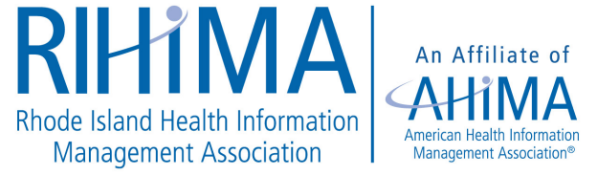

Program Agenda Fall Meeting
October 18th, 2019 8:00 a.m. – 12:30 p.m.
Trowbridge Center
10 Health Lane, Education Room 4B
Warwick, Rhode Island 02886

8:00 a.m. - 8:30 a.m. Registration; Continental Breakfast

8:15 a.m.-8:30 a.m. RIHIMA Business Meeting

8:30 a.m. – 9:30 a.m. A Day in the Life of a Central Cancer Registrar
Nicole Witherell
Data Quality Coordinator and Cancer Registrar

9:30 a.m. -10:30 a.m. Selected FY 2020 Coding Topics
Barry Libman, MS, RHIA, CDIP, CCS, CCS-P
President, Barry Libman Inc.

10:30 a.m. – 11:30 a.m. Payback Audits and the Steps Involved
Joy Rose, MSA, RHIA, CCS, CHPS Senior Healthcare Consultant, Womble Bond Dickinson (US) LLP

11:30 a.m. -12:30 p.m. The Public Impact of the Opioid Crisis
Justin Alves, RN, ACRN, CARN
Addiction Nurse Educator for the OBAT-TTA,
Boston Medical Center

This program offers 4 (four) continuing education units (CEU’s)

