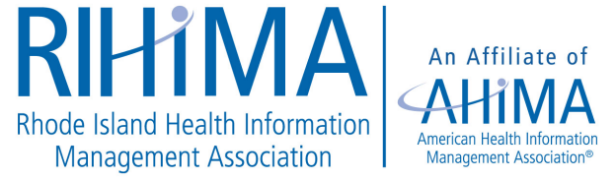

Program Agenda Virtual Fall Meeting
October 13th, 2023
8:00 a.m. – 12:30 p.m.

8:00 a.m. - 8:30 a.m. Check In/RIHIMA Updates

8:30 a.m. – 9:30 a.m. Current Auditing Responses from Hospitals &Practices
Sandy Giangreco Brown, MHA, BS, RHIT, CCS, CCS-P, CHC, COC, CPC, CPC-I, COBGC , PCS
Director of Coding and Revenue Integrity
Clifton, Larson, Allen LLP

9:30 a.m. -10:30 a.m. Making the Right Choice, Ethics in Healthcare, a Non- Clinical
Perspective
Dr. Kengia Sabree, RHIA, CCA, CAHIMS
CEO, The Qualified, Inc.

10:30 a.m. – 11:30 a.m. Change is Coming: ICD-11 Planning
Michelle Badore
Global Clinical & Nosology Content Manager
3M Health Information Systems

11:30 a.m. – 12:30 p.m. Not Your Mommas HIPAA
Marianne Durling, MHA, RHIA, CCS, CPC, CDIP, CPCO, CIC, CDEI, CPC-I
Compliance Director

This program offers 4 (four) continuing education units (CEU’s)

